Tabling and Marching Materials- Cart List for Website
6’ Table Throw Personalized to your Local Group (Only 1) http://www.totallytablecovers.com/store/6-table-throw-1-color-imprint-on-front.html
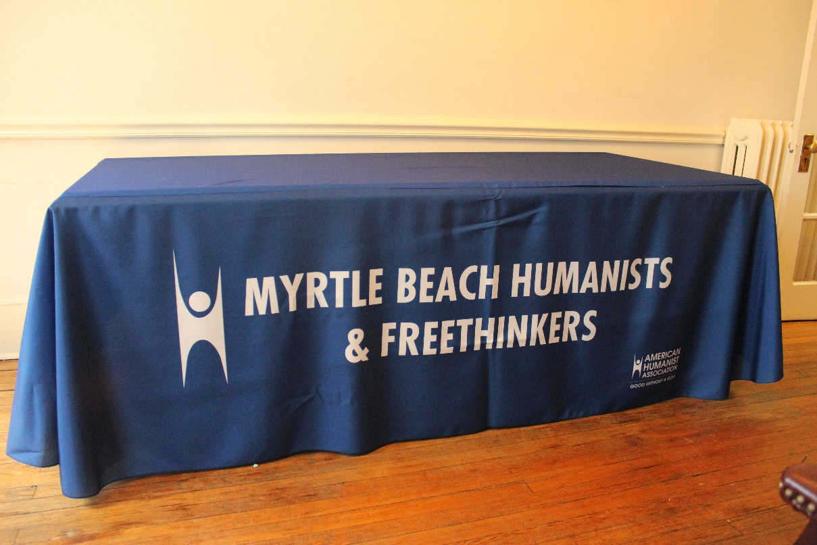

Marching Banner Personalized to your Group (Only 1) http://www.vistaprint.com/custom-banners.aspx?GP=9%2f10%2f2015+11%3a43%3a30+AM&GPS=3608049901&GNF=1
- Order 2.5 x 8
- Vinyl and Outdoor
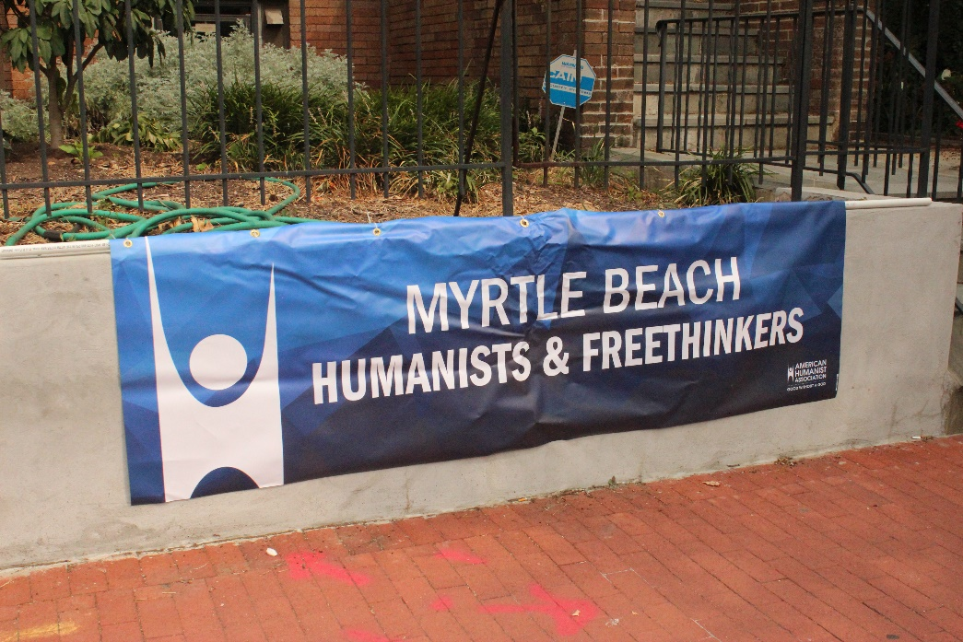
Business Cards Personalized to your Group http://www.vistaprint.com/category/business-cards.aspx?GP=9%2F10%2F2015+12%3A21%3A56+PM&GPS=3608049901&GNF=1
- Standard
- Any Information about Group you would Like
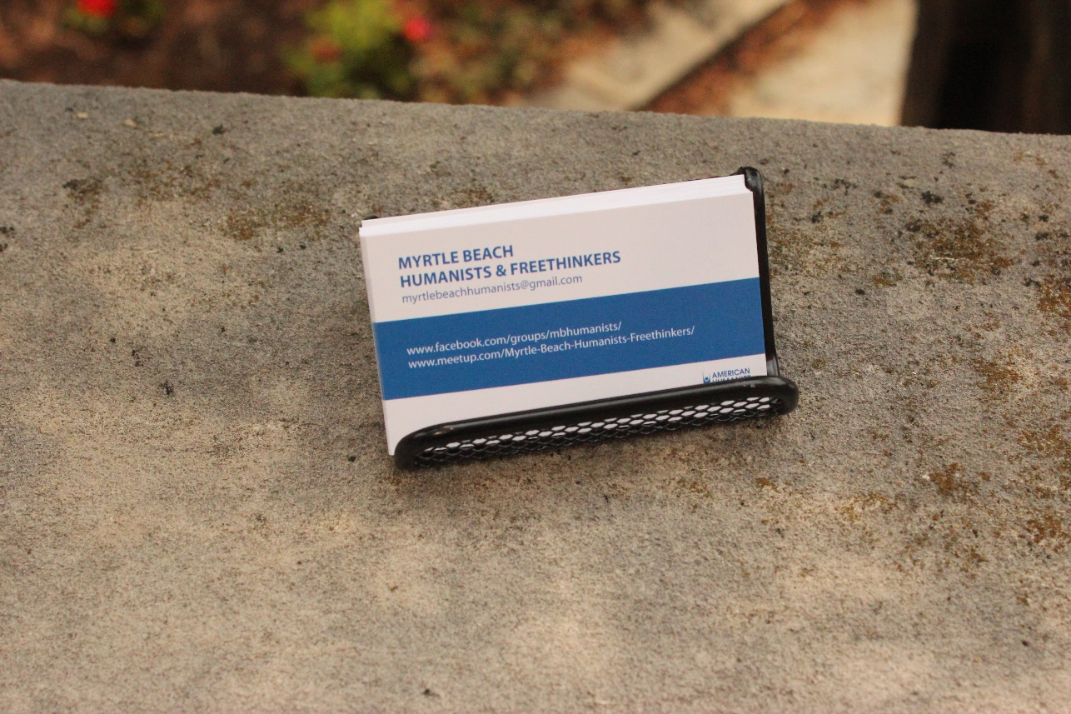

T-Shirts Personalized with your Groups Name and Logo
- http://www.customink.com/styles/american-apparel-jersey-t-shirt/15000
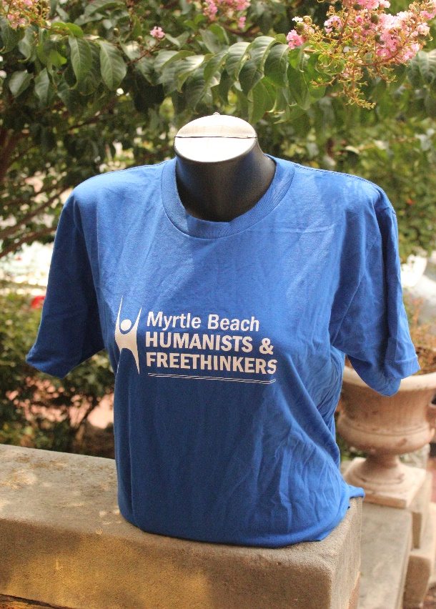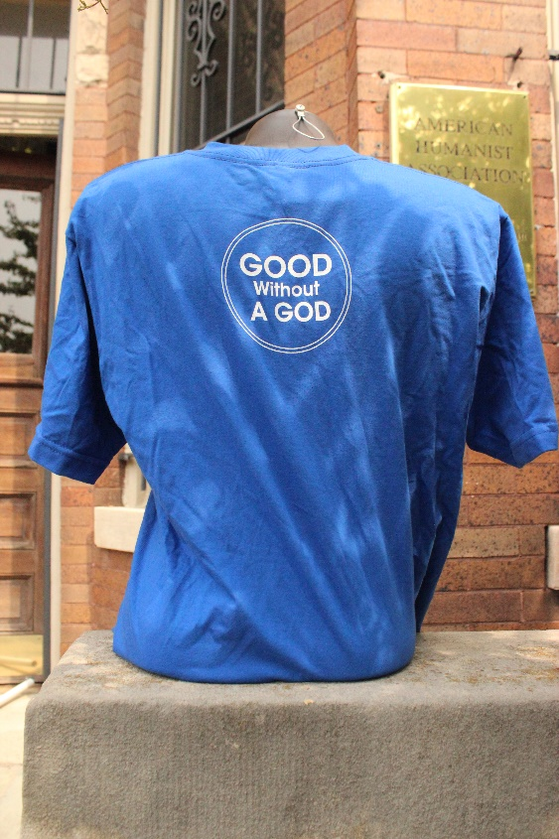

Metal Magazine Holders ( Every group should have at least 2) http://www.palaydisplay.com/Metal-Tech-Small-Metal-Brochure-Holder-p-22954.html
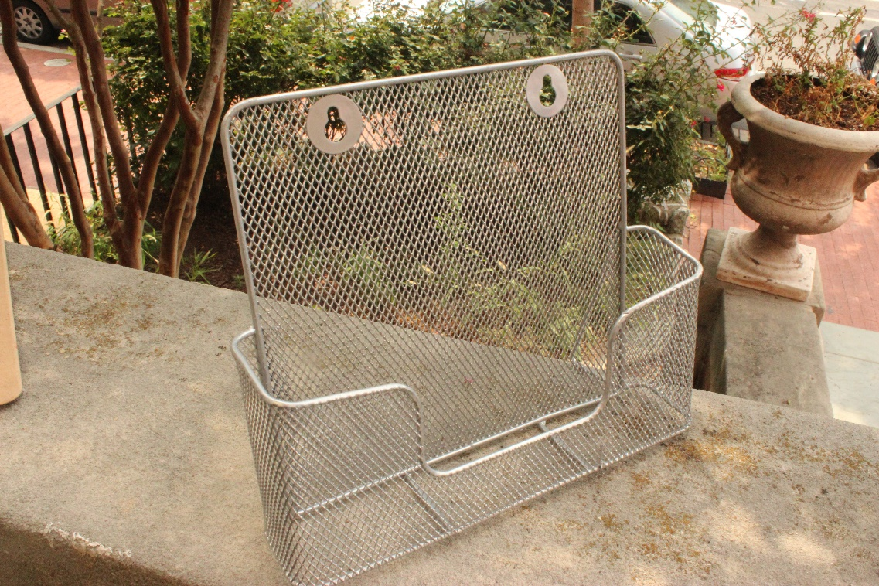
Metal Brochure Holder (Every group should have at least 2) http://www.palaydisplay.com/Metal-Tech-Small-Metal-Brochure-Holder-p-22954.html
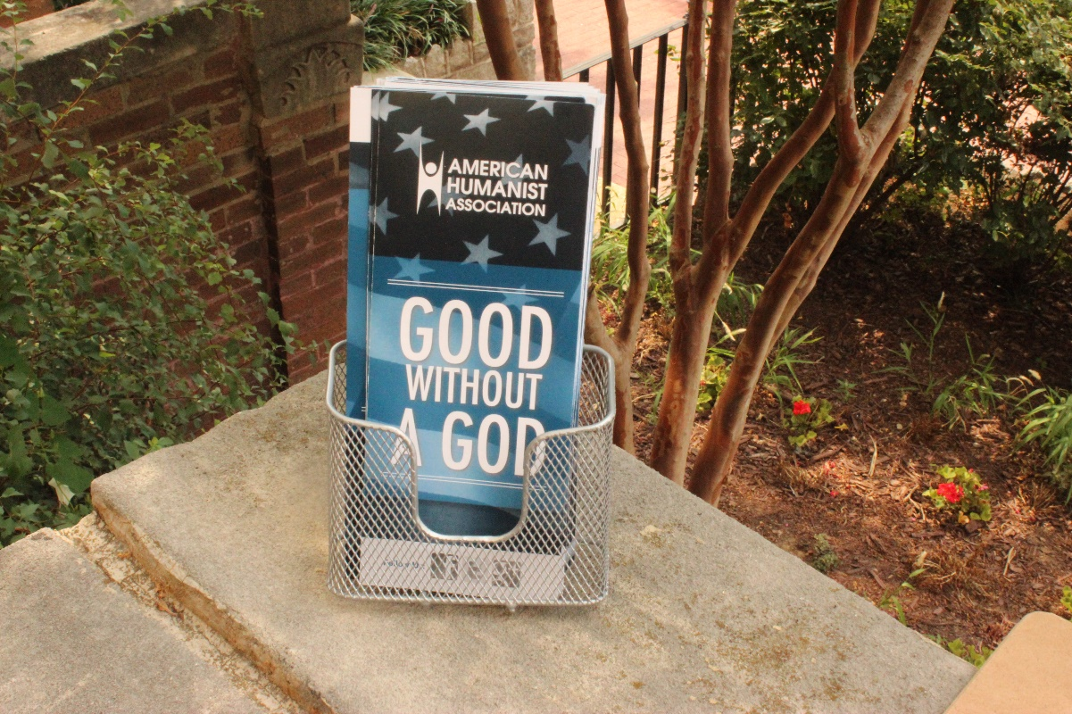

Acrylic Sign Holders (Groups should have at least 3) http://www.amazon.com/Source-Inches-Holder-Slant-SB-5X7-3P/dp/B00KLMFISQ/ref=sr_1_13?ie=UTF8&qid=1424898469&sr=8-13&keywords=acrylic+sign+holder
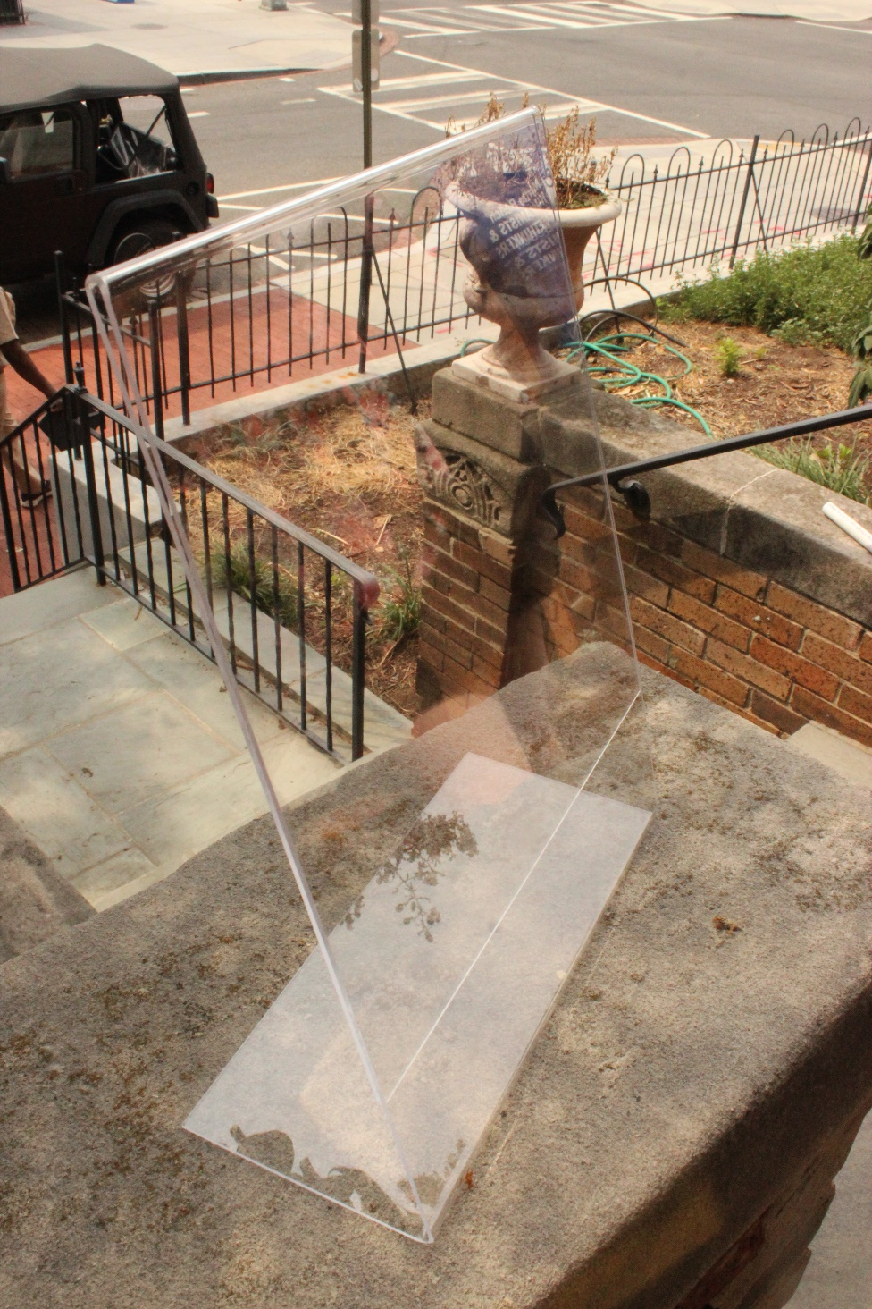

Clipboards (Groups should have at least 2) http://www.quill.com/letter-size-hardboard-tan-clipboards/cbs/216360.html?promoCode=200200555&Effort_Code=901&Find_Number=717643
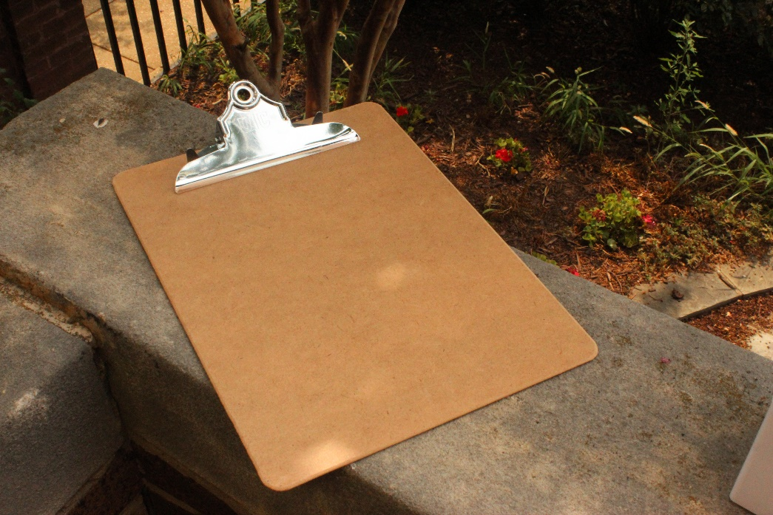
Pen Cup (Groups should have at least 1) http://www.quill.com/poppin-pen-cups/cbs/910921.html?effort_code=901&promoCode=400090029&find_number=49000POP
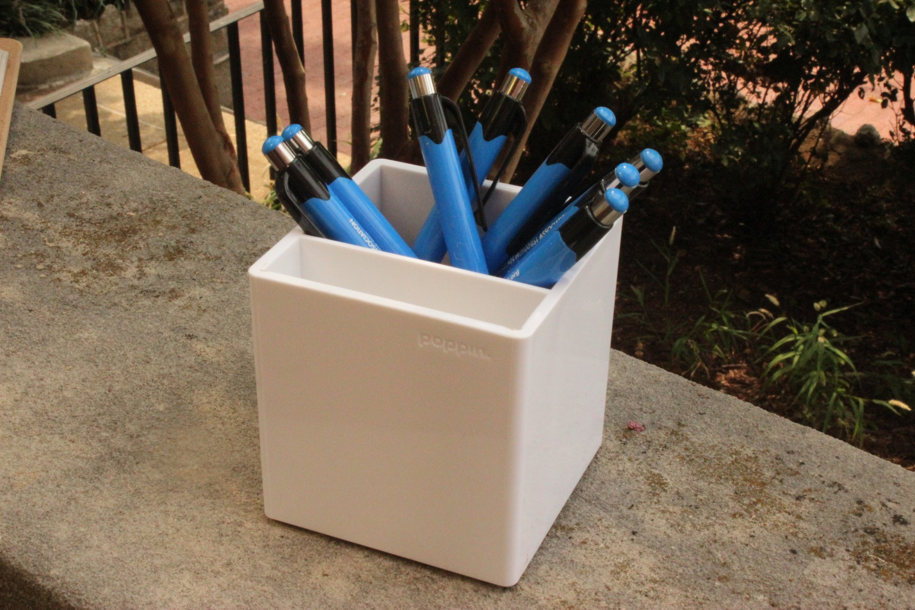

Business Card Holder (http://www.quill.com/quill-brand-wire-mesh-desk-accessories/cbs/392206.html?cm_mmc=SEM_PLA_OS_392206&mcode=SEM_PLA_OS_392206_)
